ALLIANCE UNIVERSITY
Alliance College of Engineering and Design

Student-Centred and Industry-friendly
OBCFC Course Structure

PART B – Micro–Project Report

Course Code: E1CSA25202 Course Title: Programming in Python

Name of Course Incharge: Mr.Deepak Raj T

Library Management: Track books, handle issuing/returning, and maintain availability status

1.0 Rationale
Libraries manage a large collection of books and records, which becomes difficult when handled manually. Manual systems are time-consuming, error-prone, and inefficient, especially when tracking book availability, issuing, and returning books. Misplaced records and incorrect entries can lead to confusion and delays.

This project focuses on developing a Library Management System using Python to automate these tasks. The system allows adding books, issuing books, returning books, and displaying records efficiently. It ensures accuracy, reduces human effort, and provides quick access to information. This project demonstrates the application of programming concepts in solving real-world problems and improves system efficiency.

2.0 Competency of the Course
- Apply Python programming concepts to develop real-world applications
- Design menu-driven programs
- Implement data structures like lists and dictionaries
- Handle user input and validations

3.0 Course Outcomes Addressed
- CO2: Apply control structures in Python
- CO3: Develop Python programs using functions and data structures
- CO4: Solve real-world problems using programming

4.0 Literature Review

Library management has evolved from manual record-keeping to computerized systems. Traditional methods relied on registers, which were prone to errors and inefficiencies. Modern systems use software to automate operations such as book tracking, issuing, and returning.

Various studies show that automation improves accuracy and reduces workload. Programming languages like Python are widely used for such systems due to simplicity and flexibility. Basic systems use lists or databases to store records and provide user-friendly interfaces.

This project is based on a simple command-line system, which demonstrates fundamental concepts of software development without requiring complex tools or databases.

5.0 Actual Methodology Followed
- Identified problems in manual library system
- Designed system with features:
- Add Book
- Issue Book
- Return Book
- Display Books
- Used Python dictionary to store book records
- Created menu-driven interface
- Implemented validation checks
- Tested system with different inputs

6.0 Actual Resources Used (Mention the actual resources used).

S. No. | Name of Resource/material | Specifications | Qty | Remarks
 | COMPUTER | WINDOWS | 1 | CODING
 | PYTHON | VERSION 3.x | 1 | PROGRAMMING
 | IDE | VS CODE | 1 | DEVELOPMENT

7.0 Outputs of the Micro–project

OUT PUT:

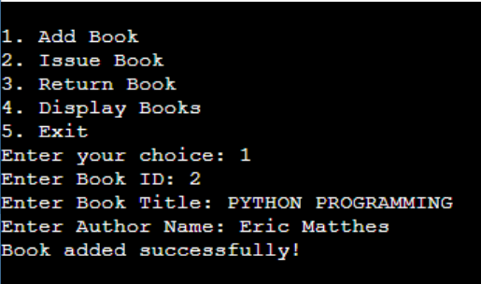

CODE USED:

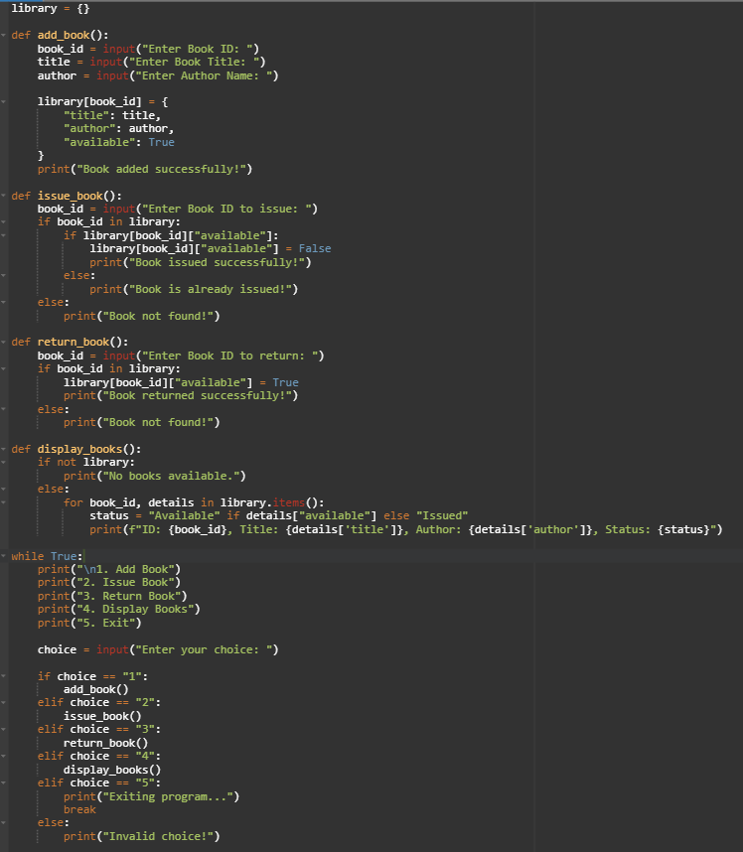

8.0 Benefits of this Micro–project

This micro-project helps in reducing manual errors and improves the efficiency of library operations. It saves time by automating tasks like adding, issuing, and returning books. The system ensures accurate tracking of book availability, which avoids confusion and duplication of records. It is user-friendly and easy to operate, even for beginners.

9.0 Area of Future Improvement

- Add database (MySQL)
- GUI using Tkinter
- User login system
- Barcode integration

10.0 References

- Python Documentation, “Python 3 Documentation,” [Online]. Available: https://docs.python.org
- StudyTonight, “Library Management System in Python”
- GeeksforGeeks, “Python Projects”

*********

